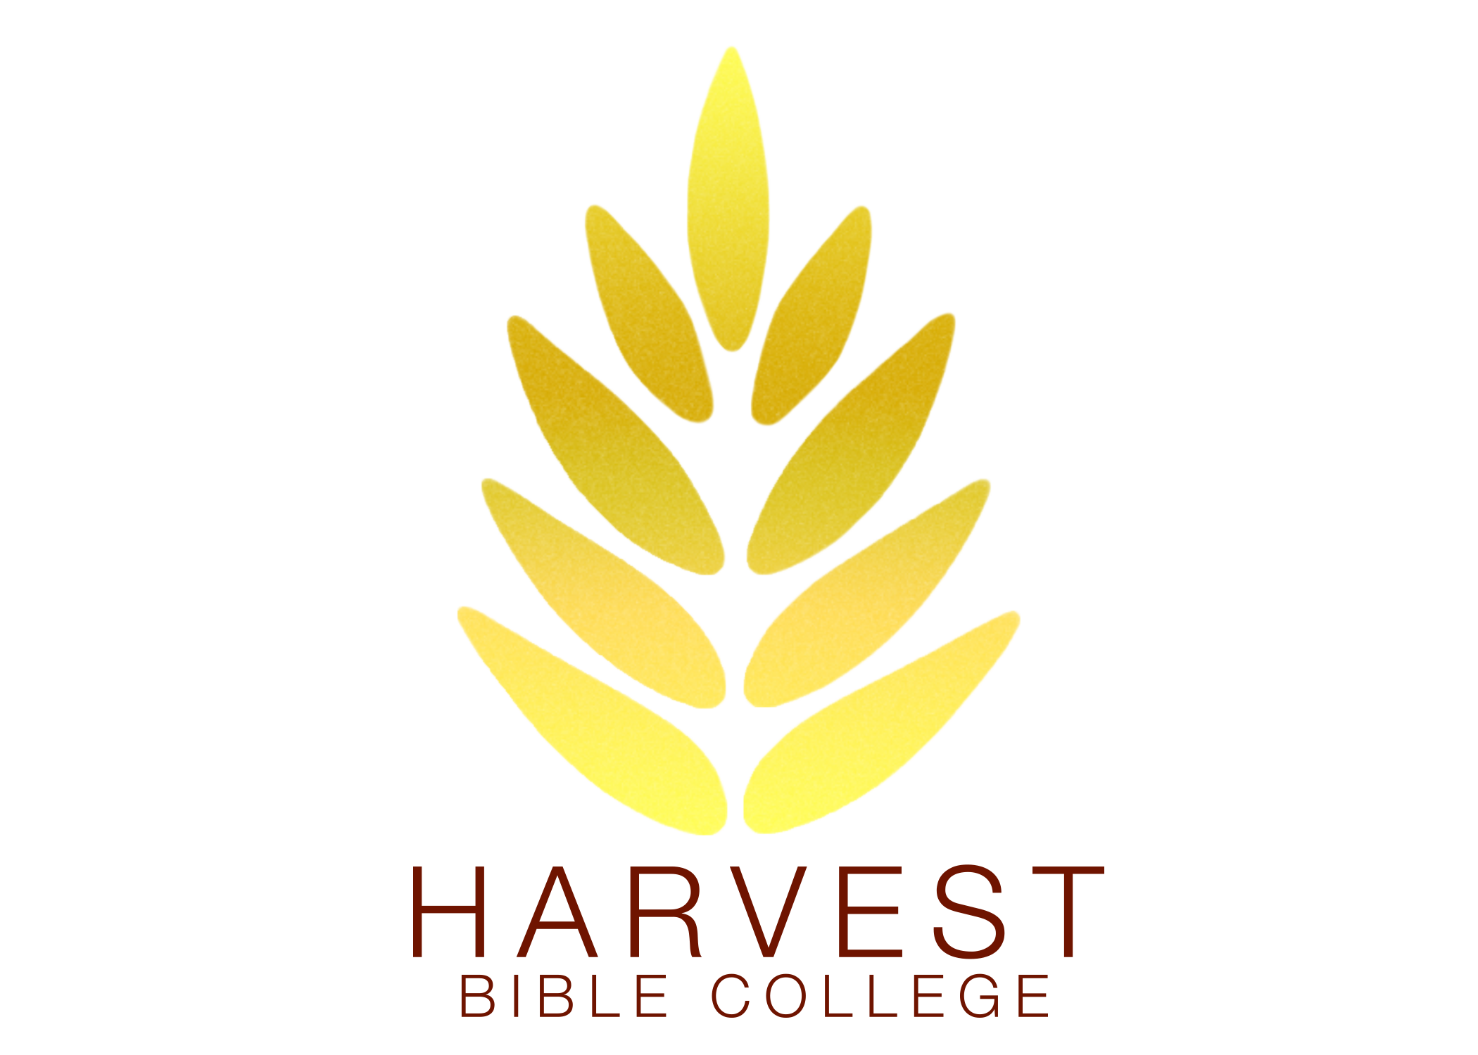

APPLICATION CHECKLIST
- Pastor’s approval for attendance
- £50.00 non-refundable application fee
- Signed application w/pastor’s signature
- Send required documents by email to hbcgbi@aol.com

NORTH AMERICAN APPLICANTS ONLY

- Apply for your AIM Education extension
- Verify that your Visa is current through 3 July 2021

